Prospective New Member  The Coral Company  Independence, OH | 
Last Updated: Apr 17, 2025 by Jacob Teich

Deal Overview
tl;dr
- Thesis: Acquire an association management company in a large metro area (Cleveland) from an owner whom TCC has developed a very strong relationship with
  - TCC first met the owner of Coral (Peter Rubin) about a year ago and we have developed a good relationship with him; Peter attended Collectivity in 2024
  - TCC submitted an IOI in May’24 at 7.0x EBITDA ($300K of EBITDA) plus a 3-yr earnout
  - Coral experienced a cyber attack in Jun’24 where a hacker stole funds ($1M) from a client’s bank account due to a former employee mistakenly authenticating a foreign actor. They put their sale process on hold but re-engaged with us in early 2025.
    - Our deal counsel has spoken to Coral about this issue and does not see any exposure for the company in the future from this incident. Coral paid back the money to the customer already.
- Key stats (TTM 1/31/25):
  - $6.5M PF Rev & $515K PF QoE Adj. EBITDA (19% margin)
  - 81 CAs / 11 Rentals, 9.1K doors, 78 FTEs (53 Onsite / 25 Corporate)
  - 3-yr average retention: 90% door, 89% logo, 75% employee
    - 2024 CA retention: 92%
  - CAM Cut: 40% (includes assistant managers)
  - Revenue Mix (excluding on-site payroll pass-through revenue): 74% Mgmt fees, 7% Transfer fees, 11% addendum fees, 8% bank earnings credits
- Opportunities / Growth:
  - Institute a small markup on $3.3M dollars of on-site labor passthrough revenue; currently Coral is charging no markup on-site salaries (CWD Group charges a 10-12% markup for on-site employee salaries)
  - Grow addendum revenue; Coral has historically billed very little addendums but instead has higher base management fee pricing (all-inclusive pricing model similar to New Washington Land Company)
  - Expand into the other major cities in Ohio (Columbus, Cincinnati) and expand the sales / business development function: Peter is the only person doing any selling today
  - Potentially can improve the EC agreement with Alliance. Current agreement is currently on par with TCC AAB agreements but we are engaging Alliance right now to renegotiate for a better TCC-wide agreement.
- Considerations / Risks:
  - Cyber attack in June 2024 which was challenging; which cost Coral about $800K in total.
    - Potential for future customer churn after the cyber attack
      - Mitigant: Peter indicated that the impacted customer agreed to a non disclosure agreement after being made whole, which should limit reputational risk
      - We continue to view this risk as limited. TTM retention is 92% and no signs that they are losing clients this year.
  - Owner transition; this would be a small member company, and Peter (current CEO and owner) carries the brand and leads business development
    - Mitigant: Peter has president who leads much of the management function, and has a couple of management team members below him that could step into his role
- Software and Banking:
  - Client Accounting: App Folio
  - Corporate Accounting: App Folio
  - Transfer & Resales: HomeWise
  - Payroll: CBIZ
  - Client Banking: Alliance
- Transition Plan:
  - Roles
    - Peter Rubin: current owner and CEO.
      - Oversees operations and strategy for the company
      - Some of the CAMs report to Peter
    - Alexis Willman: President
      - Manages properties and manages a team of CAMs
    - Kelly D’Amico: VP of Accounting
      - Oversees corporate and client accounting
    - Janelle DeAngelo: VP of Association Management
      - Manages hiring, benefits, training, etc.
  - Who is there now that won’t be there post-close?
    - Peter is looking to transition out of his role over the next 2-3 years
    - Current director of maintenance has been with Coral for 21 years and may retire this year
- Other relevant info:
  - Coral Data Room
  - Coral Info Sheet
  - Coral Pre-LOI Databook
  - Coral Diligence Workbook
  - Coral Info Call
  - Coral + TCC PD 28 Dec 2024
  - Coral + TCC Catch-up 10 Jan 2025
- Deal Structure:
  - Propose an LOI for an MC opportunity structured as:
    - $3.8M EV @ Closing (7.25x PF EBITDA)
      - $3.2M Cash at Closing
      - $0.6M Seller Note
      - 2027 earnout paying 7.25x any incremental EBITDA above $707K (10% annual EBITDA CAGR)

Transaction overview
The Coral Company, based in Independence, Ohio (Cleveland metro area) is an association management company with ~80 employees (majority are on-site) serving ~80 CAs (plus small rental and commercial portfolios) and 9.0K units. The portfolio is about 55% condo associations with the remainder being HOAs (29%), rentals (11%), and commercial (4%). Coral serves largely higher-end communities that often want dedicated on-site staff. The Company is 100% owned by Peter Rubin who founded the Company in 1987. Prior to founding Coral, Peter was a real estate attorney in New York serving as COO of a national real estate firm.

Transaction Details
Underwriting EBITDA and Valuation (Member Company)
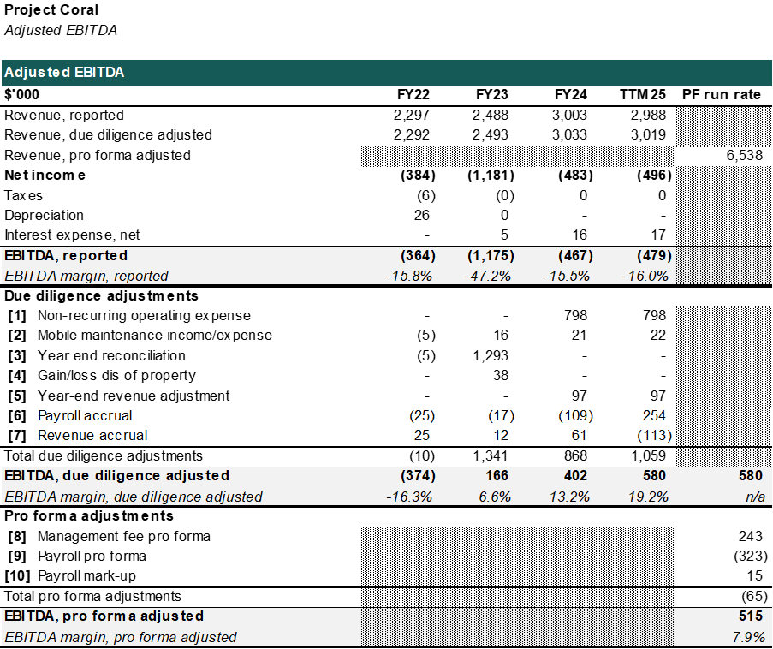

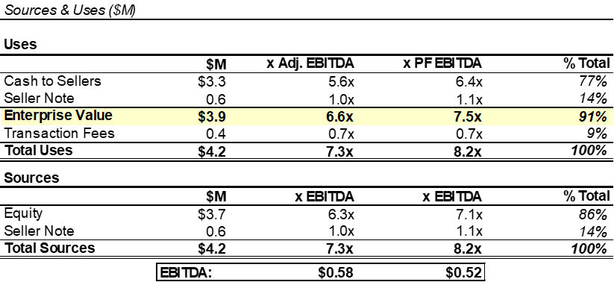

Commentary:

Revenue is presented net off pass-through on-site payroll revenue - this is the same way that TCC financials are presented.

Adj. EBITDA: The primary adjustments to EBITDA are as follows:
- Adjustment 1 backs out the expenses related to the cyber attack.
- Adjustment 3 is a non-cash non-operating adjustment related to work Coral did to clean up their balance sheet (correction to retained earnings); Adjustment 4 is similar, but specifically relates to out of period bad debt write offs
- Adjustment 6 is a standard cash-to-accrual adjustment for corporate payroll and on-site pass through payroll revenue.

PF EBITDA: Annualizes upcoming customer wins and losses and utilizes 2025 management fee rates. Also utilizes the 2025 payroll roster which is a negative adjustment.

Valuation: 7.25x LOI EBITDA at closing with 15% in a seller note. This equates to 7.3x diligence adjusted EBITDA, and 7.5x PF Adj. EBITDA.

Seller Note: 3-year term with a 6.5% interest rate. The principal will amortize evenly over 3 years and pay quarterly interest payments.

Earnout: 7.25x any incremental EBITDA above 10% per year growth in 2027

Employment Agreement: Peter will sign a 2.5 year employment agreement (through 2027) at an initial salary of $184,000. Peter may look to begin transitioning out of the business ahead of that timeline.

Source: Coral Diligence Workbook

Customer Analysis
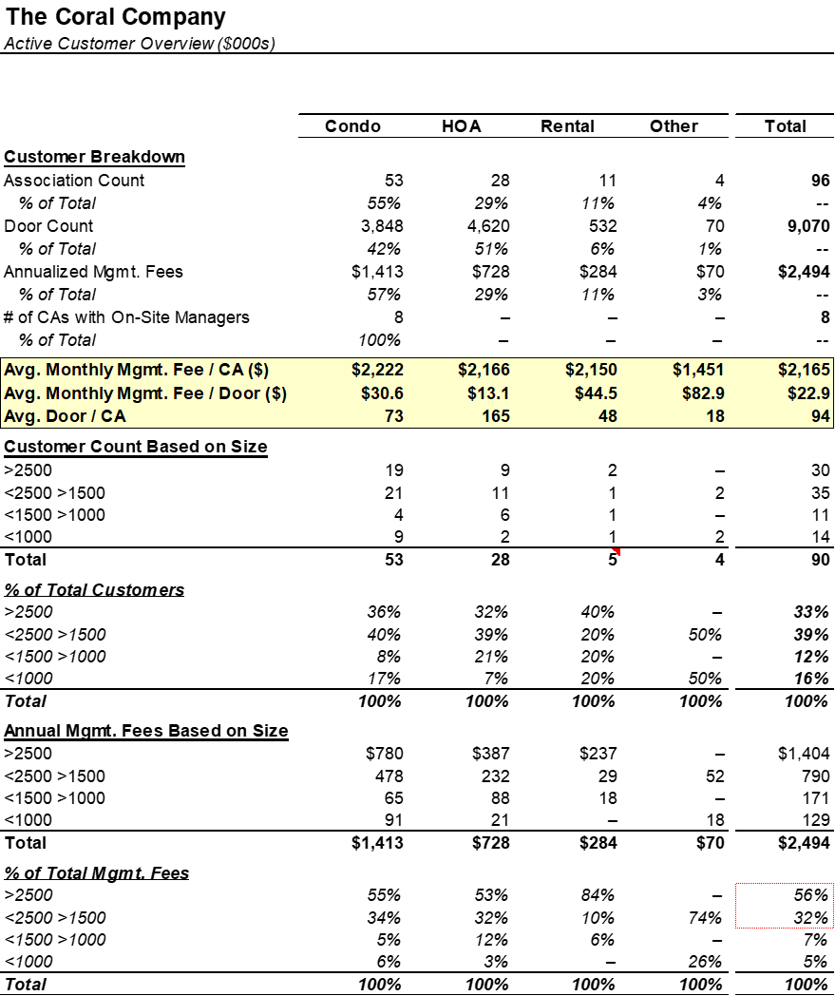

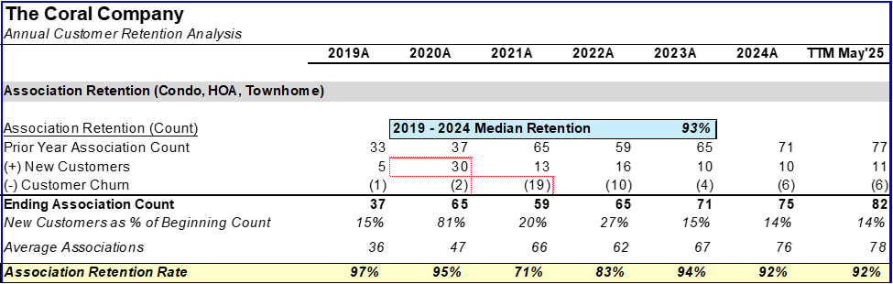

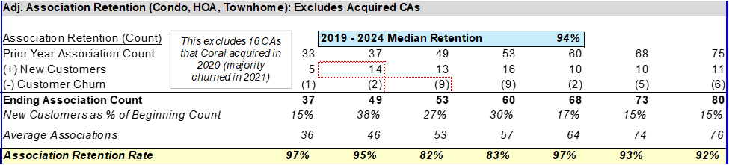

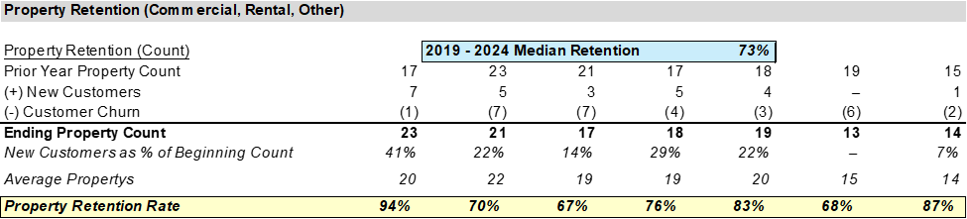

Commentary:

Coral has historically had strong association customer retention greater than 90% each year. This trend temporarily halted during 2021 and 2022. During this period, there were two key drivers of higher churn.
The first was a small acquisition that was completed in 2021, which included a portfolio of accounts that were typically smaller and less profitable than Coral’s primary book of business. As a result, a larger number of accounts churned during this period. Additionally, Coral went through a period of portfolio rationalization, and moved on from select accounts that were less desirable for the business. The first two sets of analyses above show the customer retention trends inclusive and exclusive of the acquired accounts.

Rental and commercial properties have historically had higher churn rates, in line with industry norms. Rental is not a focus anymore, and Coral is not seeking any new business in rental.

Source: Coral Diligence Workbook

Employee Breakdown
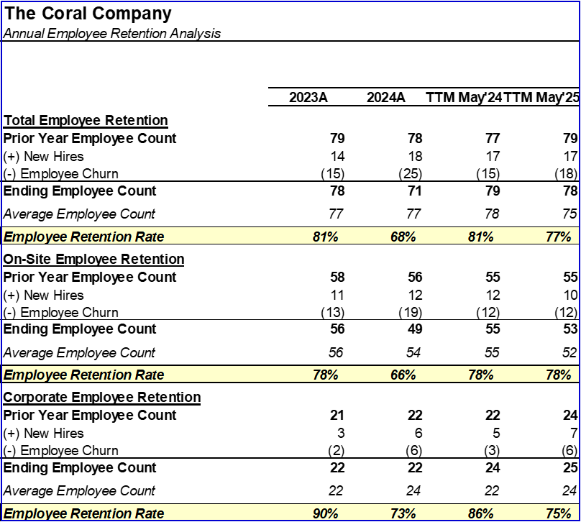

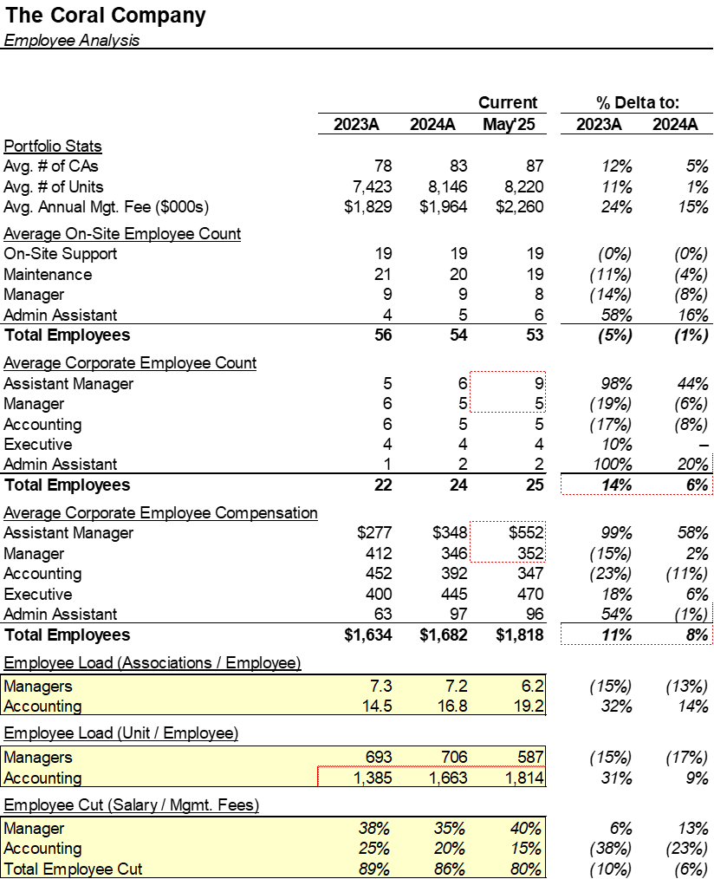

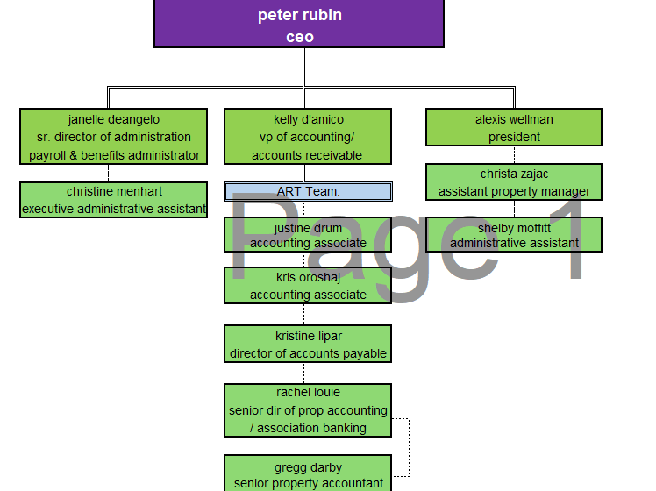
Commentary:

Coral maintains a significant on-site employee base, which includes 8 property managers and ~45 building staff across maintenance and support. Historically, Coral has not charged a markup on these individual’s salaries, but has begun adding this as of January 2025. Widespread adoption of a markup is a significant revenue and profit opportunity for the Company. Onsite roles, particularly support roles (e.g., front desk), have historically had higher turnover rates, particularly for less desirable positions such as night shifts.

For managers with portfolios, Coral’s strategy is one of internal development. All managers are initially hired as assistants, and are then promoted after ~1 year or moved out of the business. Managers typically oversee ~7 accounts individually, and will take an on an assistant to support a larger portfolio thereafter. The Company has historically had strong employee retention at the corporate level.

At the executive level, Peter’s core team is three individuals. Janelle Deangelo is the Sr. Dir. of administration, and oversees HR, recruiting, and training functions. Kelly D’Amico is VP of accounting and leads financial reporting, and Alexis Wellman is the President. Peter and Alexis each oversee approximately half of the manager organization.

Source: Coral Diligence Workbook

Long-Term Financials
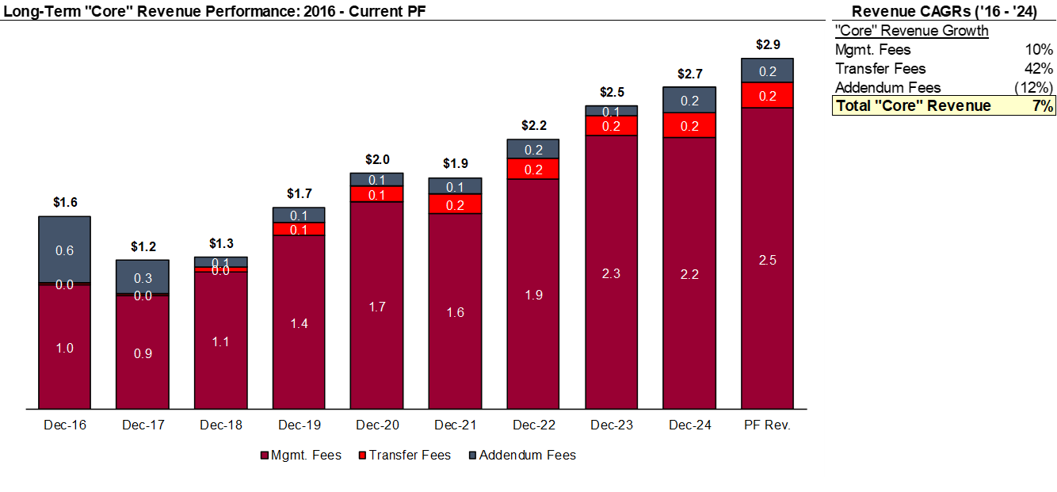Commentary:
Coral has successfully grown its management fee base over the past several years, nearly doubling since pre-Covid. The Company has historically used an all-in pricing strategy, so addendum billings have been minimal. While not wanting to abandon their historical pricing methodology, management has identified capital project management as a potential area where they could drive additional revenue.

Reimbursed revenue has historically been a pass through for Coral, though, as previously mentioned, the Company aims to begin capturing a small markup on this revenue. This book of business has grown at a GDP+ CAGR for the past several years, with a temporary spike in 2020.

Source: Coral Diligence Workbook

On-Site Payroll Markup Opportunity
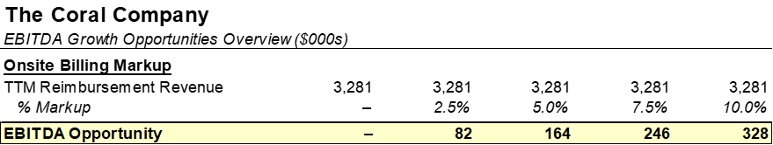

Commentary:
Coral has not historically charged any markup for the onsite employees it manages. Such markups are a standard industry practice to compensate for the administrative burden of managing these employees, and Coral believes it has the opportunity to add in a markup moving forward. The above details a range of markups between 0 and 10%, which are highly achievable.

New onsite customers in 2025 are being onboarded with a 5% markup on pass-through payroll costs (3 CAs so far which will generate $15K of annualized EBITDA)

Source: Coral Diligence Workbook

Capital Projects Billing Opportunity
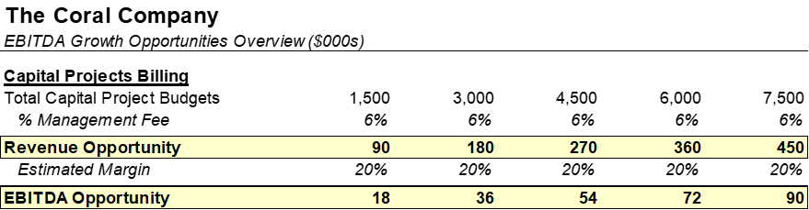

Commentary:
While Coral has historically practiced an all-in premium pricing strategy, management has identified capital project management as an area where they would like to amend their billing practices to drive growth. By charging a 6% management fee on program budgets (in line with other MCs, notably Hales) Coral would have the opportunity to grow EBITDA by 10-20%, with significant further upside if project volume increased.

Source: Coral Diligence Workbook

